Introduction
This document describes the light, vibra, power and FM Transmitter (FM Tx) plug-in API of the HW Resource Manager.
HW Resource Manager is a client-server solution that utilizes ECom plug-ins to achieve device independency. There is a separate plug-in implementation for lights, vibra, power and FM Tx, although they all use the same interface.
HW Resource Manager provides client APIs for controlling lights, vibra, power and FM Tx of the device. It also has additional responsibility of publishing certain power state related P&S (Publish and Subscribe) properties.
Licensees must implement vibra, light, power and FM Tx plug-ins to allow the actual vibra, light, power and FM Tx hardware to be controlled.

List of required interfaces
HW Resource Manager resource plug-in API requires ECom framework from Symbian, as ECom is the mechanism that is used to load plug-ins to HWRM Server.
Some sort of domestic operating system interface is also required by plug-ins to control the actual resource. This varies from device to device and is the responsibility of licensees to implement.

Constraints
HW Resource Manager and the light and vibra APIs are valid from Symbian OS v9.4 onwards. The power and FM Tx APIs are valid from Symbian OS v9.5 onwards

Technical specification

Type of interface
This API is implemented as an ECom plug-in and hence is loaded through the ECom framework.
Type of the interface is asynchronous method call. All functionality is accessed through abstract class CHWRMPluginService.

Interface class structure
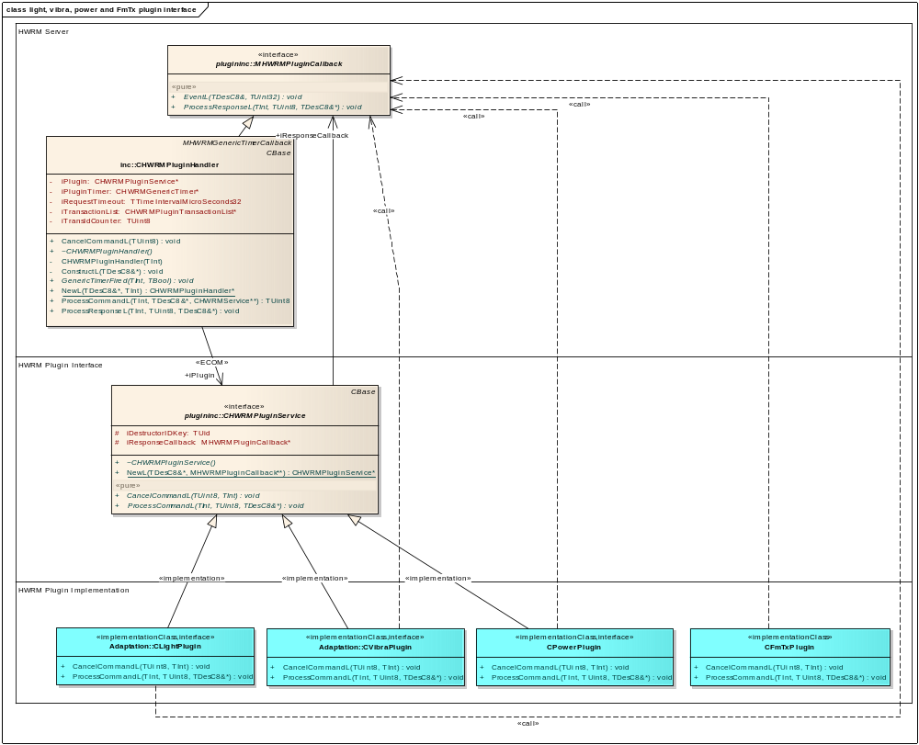
Figure 2.1 HWRM plug-ins class structure
The CLightPlugin, CVibraPlugin, CPowerPlugin and CFmTxPlugin classes represent the actual implementation of the plug-in that is responsible for accessing lights, vibra, power or FM Tx through the product specific hardware interface. CLightPlugin, CVibraPlugin, CPowerPlugin and CFmTxPlugin should be derived from the CHWRMPluginService class that handles instantiation of the implementation via ECom.
CHWRMPluginHandler from the HWRM Server implements the MHWRMPluginCallback interface class and creates the instance of the plug-in. A pointer to itself is passed to the plug-in to allow command responses to be passed to it from plug-in via ProcessResponseL() and EventL() methods.
Namespaces HWRMLightCommands, HWRMVibraCommands, HWRMPowerCommands and HWRMFmTxCommands define constants, command identifiers and parameter packages to be used with light, vibra, power and FM Tx plug-ins respectively.

Usage

Protocol
An instance of class implementing CHWRMPluginService is created with the factory method CHWRMPluginService::NewL(), which takes a matching string and callback pointer as parameters. Since multiple resources use the same interface, there are multiple implementations of this interface. The matching string parameter identifies the plug-in implementation to load. Callback pointer (MHWRMPluginCallback) provides a response channel to plug-in.
The matching string can be HWRMLight, HWRMVibra, HWRMPower or HWRMFmTx to load light, vibra, power or FM Tx plug-in, respectively.
The usage of API is straightforward: HWRM Server calls ProcessCommandL() to inform the plug-in that something needs to be done, supplying the exact command ID, unique (concurrent uniqueness only, as there are only 256 different possible IDs) transaction ID and command data as parameters. Plug-in checks data validity and starts processing command asynchronously. After the plug-in has completed processing the command request, it calls the callback method ProcessResponseL() with matching command ID, transaction ID and response data package defined by command. Typically, the data package contains only error code.
The API also provides EventL () callback method to notify the CHWRMPluginHandler about events from a HWRM plug-in. The method will return in its parameters an indication ID which distinguishes between different types of events and an indication data package that contains any data related with the event.
Command IDs, indication IDs and data package definitions are found in command definitions headers, specifically HWRMLightCommands.h, HWRMVibraCommands.h, HWRMPowerCommands.h and HWRMFmTxCommands.h.
If ProcessCommandL() call leaves because of an error in data validity checking or some other reason, it will not initiate the asynchronous operations. I.e. if it leaves, there will not come a ProcessResponseL() call relating to this transaction later.
ProcessCommandL() and ProcessResponseL() pair is always called asynchronously, i.e. call to ProcessResponseL() always comes after ProcessCommandL() exits.
HW Resource Manager Server can cancel the ongoing asynchronous command processing by calling CancelCommandL() with identifying parameters. If processing of a command is cancelled in this fashion, there will not come ProcessResponseL() call relating to that transaction later.
The plug-in supports multiple concurrent calls on the same resource. Only the latest call for each subresource (such as light target) remains in effect, if the target subresources of concurrent calls overlap.
For example, suppose there comes a Light On command targeting display light and keyboard light, and then immediately after that (before the plug-in had a chance to call ProcessResponseL() for previous command) a Lights Blink command targeting just display lights. In this scenario, display lights would start blinking while keyboard lights would stay just on.

Error handling
HW Resource Manager Server routes all errors as-is to client.

Memory overhead
HW Resource Manager memory overhead is implementation dependant.

Extensions to the API
This resource API can easily be expanded to apply to other resources than vibra, lights, power and FM Tx. A new command definition header is required, as well as new implementation; the methods themselves are generic enough for all conceivable resources.

Plug-in configuration
The HW Resource Manager resource plug-in APIs are implemented as a standard Symbian OS ECom plug-ins. For further ECom implementation guides refer to the Symbian ECom documentation.
Note: As is usual with the ECom architecture, special care must be taken when writing the resource files. When implementing this plug-in, the resource file must implement the interface_uid of 0x10205028, the default_data must equal HWRMLight, HWRMVibra, HWRMPower or HWRMFmTx and rom_only must equal 1.
Without these conditions the plug-in implementation will not load correctly.
Here is an example resource file demonstrating the correct values (pay special attention to the attributes show in red):

#include "RegistryInfoV2.rh"

// Declares info for two implementations
RESOURCE REGISTRY_INFO theInfo
{
resource_format_version = RESOURCE_FORMAT_VERSION_2;
dll_uid = 0x12345678;
interfaces =
{
INTERFACE_INFO
{
// UID of interface that is implemented
interface_uid = 0x10205028;
implementations =
{
IMPLEMENTATION_INFO
{
implementation_uid = 0x11223344;
version_no = 1;
display_name = "Light plugin stub";
default_data = "HWRMLight";
opaque_data = "";
rom_only = 1;
},
IMPLEMENTATION_INFO
{
implementation_uid = 0x55667788;
version_no = 1;
display_name = "Vibra plugin stub";
default_data = "HWRMVibra";
opaque_data = "";
rom_only = 1;
},
IMPLEMENTATION_INFO
{
implementation_uid = 0x12332112;
version_no = 1;
display_name = "FM Tx plugin stub";
default_data = "HWRMFmTx";
opaque_data = "";
rom_only = 1;
},
IMPLEMENTATION_INFO
{
implementation_uid = 0x44332211;
version_no = 1;
display_name = "Power plugin stub";
default_data = "HWRMPower";
opaque_data = "";
rom_only = 1;
}
};
}
};
}

Note for light plug-in configuration:
HW Resource Manager uses the KCRUidLightSettings - KLightTargetMask CenRep key to configure supported light targets. Plug-in implementation can use the same key, if needed. This key is defined in \epoc32\include\oem\ HWRMLightInternalCRKeys.H.

Example
Example of how the plug-in interface might be called:

#include "HWRMPluginService.h"
. . .
_LIT8(KHWRMLightApiEComMatch, "HWRMLight");
iPlugin = CHWRMPluginService::NewL(KHWRMLightApiEComMatch, this);
iTransCounter = 0;
. . .
HWRMLightCommand::TLightsOnData pluginCommand;
pluginCommand.iTarget = 0x00000001; // Set target to primary display
pluginCommand.iIntensity = 50;
pluginCommand.iFadeIn = EFalse;
HWRMLightCommand::TLightsOnCmdPackage pckg(pluginCommand);
iPlugin->ProcessCommandL(HWRMLightCommand::ELightsOnCmdId, transCounter++, pckg);

Example of how ProcessResponseL() or EventL() might be handled:

HWRMLightCommand::TErrorCodeResponsePackage errPckg;
errPckg.Copy(aData);
TInt pluginErr = errPckg();
// Handle error here

Code architecture
The functionality of HW Resource Manager Plug-in Service API is defined in HWRMPluginServices.h. Light. vibra, power and FM Tx commands and related data are defined in HWRMLightCommands.h, HWRMVibraCommands.h, HWRMPowerCommands.h and HWRMFmTxCommands.H, respectively.

Further Information

References
None.

Open Issues
None.

Glossary
Term | Definition
API | Application Programming Interface
CenRep | Central Repository
DLL | Dynamic Link Library
FM Tx | FM Transmitter
HW | Hardware
HWRM | Hardware Resource Manager
P&S | Publish and Subscribe
OS | Operating System
UI | User Interface
ECom | EPOC component object model - Symbian provided mechanism for loading plug-in DLLs.
Central Repository | Symbian provided service for storing data centrally.
Resource | A HW element that needs controlled access, such as vibra or lights of the device.
Subresource | A separate target within a resource, such as display light or keyboard light. Vibra does not have subresources.

